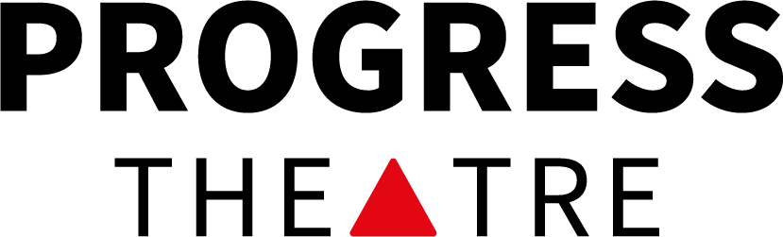
Audition Form

Name:  Preferred pronouns: |  | Date of birth if under 18:
Phone:  Email: | Address:
How would you like to be contacted if you are being offered a part?
Circle your preference: text / phone / email / any

How would you like to be contacted if you have been unsuccessful?
Circle your preference: text / phone / email / any
Previous acting experience (don’t worry if you don’t have any, or have very little):

Role preferences - list any roles you would particularly like to be considered for:

List any roles you would NOT like to be considered for:

Are you happy to be part of an ensemble and multi-role?

Rehearsals for this show will mostly be on
Weds 7.30 – 10 pm, Fri 7.30 – 10 pm, Sun 3 – 6 pm (from Sept)
Are any of these a problem for you?
Please list any dates you will not be available between
Fri 24th Jul – Sun 22nd Nov 2026

The first read through is likely to be 22nd Jul, are you available for this date? (will not affect casting)

Performance Dates are 16th – 21st Nov, including a matinee on the Saturday
Are you currently a member of Progress or Progress Youth Theatre Yes / No
(If not, you will be expected to join if cast in this production, which may entail a membership fee.)
If cast, I consent to being featured in show photography and filming, including for promotional purposes (please tick)
Content Warnings
Explicit descriptions of sexual activity
Teenage gay relationships
Adult gay relationships
Homophobia
Mysogony
Bullying
Mental illness, Isolation, Suicidal thoughts

There will be opportunities for discussions around these issues in the rehearsal process and for individuals to talk through any concerns.

Steven and John will be played by actors who are over 16.

If you are 16 - 18 please discuss this with your parents/guardians.

If you are 14 – 16 we will need written consent for you to be cast in the play.

Please let us know if you have any access needs for the audition or for future involvement in acting/tech/backstage:
For example: wheelchair access, quiet space, large print, extra time to process information, bringing a carer or interpreter, etc

Or contact www.angry@progresstheatre.co.uk if you want to discuss any requirements

Please note that due to the focus of the play we are very keen to involve people from the LGBTQ+ Community generally and, in particular, to cast Steven, John and Mr Hutton from those identifying as gay or bisexual.

If you are comfortable with this, please indicate whether you identify as:

Part of the LGBTQ+ Community ………

Gay or Bisexual ………

Or speak to Ali, Liz or Olly during the audition

Which audition will you be attending?
Fri 17th Jul 7 for 7.30 pm – 10 pm

I don’t know
Sat 18th Jul 7 for 7.30 pm – 10 pm

Content Warnings
Explicit descriptions of sexual activity
Teenage gay relationships
Adult gay relationships
Homophobia
Mysogony
Bullying
Mental illness, Isolation, Suicidal thoughts

I have reviewed the content warnings above and give permission for my child to be involved in the production of What’s Wrong With Angry at Progress Theatre.

Name of Child …………………………………………………..……………………………

Name of Parent/Guardian …………………………………………………………………..

Signature of Parent/Guardian ………………………………………………………………

